Unit 10 Assignment CECS 524 Due Nov 23, 2022 12pm

Use the C program on the back to draw the “run-time stack” as examplified in Figure 10.5 in the text. The point indicated is on a specific function and input value to the function. By the time you are asked to “draw the stack”, there should be 8 activation records on the stack already. So, in reality, “draw the stack” means “draw the stack up to this point in execution”.

I suggest either using a drawing program and even something as simple as a spreadsheet. In the cell for a stack entry I want to see:
- the variable name AND value if it’s a parameter or local variable
- the words “Return” for a return address or “Link” for a dynamic link.

Submit your assembler file in a pdf to the dropbox on BB for Unit 10 Assignment.

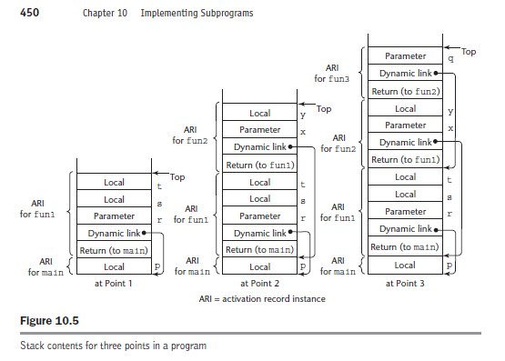
/* This program calculates the number of r element subsets in an n
element set. Ex. If n= 4 and r = 3, and the set of n elements
contains {A, B, C, D}, the value returned by comb(n, r) = 4, the
number of 3 element subsets {{A,B,C},{B,C,D},{A,C,D}, {A,B,D}}.
Output would be: There 4 3-element subsets of a 4-element set.
*/

#include <stdio.h>

void error_msg()
{
printf("Cannot be calculated with r > n\n");
}

int fact(int n)
{
if(n>1) //<===draw the runtime stack to this point
return n*fact(n-1); //there will be multiple calls to fact
else return 1; //with n=2 from on the call from (A)
}

int comb(int n, int r)
{// (A)
return fact(n) / (fact(r) * fact(n-r));
}

int check(int n, int r)
{
if(r > n)
{
error_msg();
return 0;
}
return comb(n, r);
}

void input()//assume r=4 and n=6
{
int n, r, val;
for(;;)
{
printf("Enter a value for n:"); scanf("%d", &n);
printf("Enter a value for r:"); scanf("%d", &r);
val = check(n,r);
if(val!=0)
printf("There are %d %d-element subsets of a"
" %d-element set.\n", val, r, n);
else break;
}
return ;
}
int main()
{
input();
return 0;
}

